Crowdbotics PRD

## Goals & Objectives

The purpose of this project is to build an operating system to communicate with a Raspberry Pi to control a series of peristaltic pumps in a small scale mixing station. Client has a decontamination product that will be marketed in bulk for auto shops, cleaning services, etc. Employees onsite will use these mixing stations to dispense predetermined amounts of product in three size quantities(small, medium, large). Future expectation is that the system will be expanded to add reporting capabilities via wifi to track product usage.

Requirements

*For the data model please refer it to the* [*Crowdbotics App Dashboard*](https://app.crowdbotics.com/dashboard/app/19070/)

Consumer experience

|  |  |  |  |  |
| --- | --- | --- | --- | --- |
| **#** | **User Story Title** | **User Story Description** | **Notes** | **Screen/Design** |
| 1 | Dosage pumps to be controlled by pulse count | * Pulse count for given volume to be timed by system |  |  |
| 2 | Three button options for quantities | * Quantities are to be small medium and large | For Phase One client will provide data/ possible to upscale to larger system at a later date |  |
| 3 | Stop Button | * Fourth button on home screen will be a Stop button | Stop button will stop all pumps |  |
| 4 | Flow Sensors | * Flow sensors will track actual volume dispensed for calibration |  |  |
| 5 | Calibration | * Users can test flow rate periodically in calibration screen to compare to flow meter |  |  |

Phase Two

|  |  |  |  |  |
| --- | --- | --- | --- | --- |
| **#** | **User Story Title** | **User Story Description** | **Notes** | **Screen/Design** |
| 1 | Wifi | * Wifi connectivity via usb adapter added to the control box |  |  |
| 2 | Retrieve data from box | * Box will upload, or system will query for data | No preference stated for retrieval method |  |
| 3 | Deliver data to client | * System will make usage data available to client | Possible to display data in admin panel in lieu of uploading |  |

## UI/ Wireframes

[https://app.crowdbotics.com/dashboard/app/19640/storyboard](https://app.crowdbotics.com/dashboard/app/19070/storyboard)

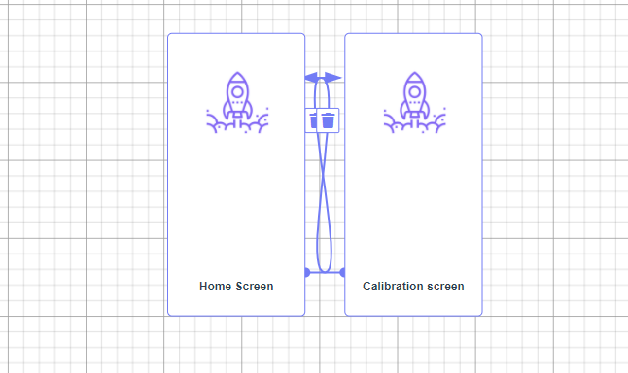

***Proposed GUI design from client****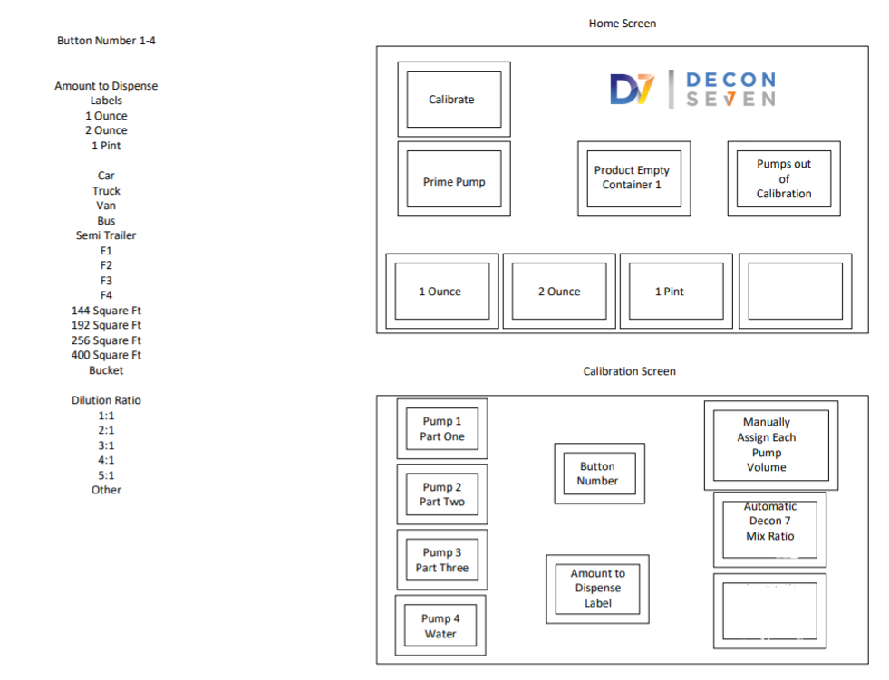*

***Control Panel design from client****